The Islamia University Bahawalpur
Department of Electronic Engineering
Faculty of Engineering


Complex Engineering Problem (CEP)
Artificial Intelligence (COMP-03661)

Submitted to:
Dr. Dileep Kumar
Submitted by:
Shahroz Chaudhary (F22BETEN1M01017)
Salamat Ali (F22BETEN1M01019)
Session:
2022 - 2026
1. Title
IoT-Enabled Edge-AI Smart Lighting Control System
2. Equipment Used
ESP32 microcontroller, LDR sensor, temperature sensor, relay module, TFT LCD display, and 5V DC power adapter.
3. Introduction
This project focuses on the development of an IoT-enabled Edge-AI smart lighting control system designed to optimize energy consumption through intelligent decision-making. By performing machine learning inference directly on the ESP32, the system reduces latency and dependency on cloud resources.
4. Methodology
The proposed system acquires real-time data from light intensity and temperature sensors interfaced with the ESP32 microcontroller. The sensor readings are normalized and processed locally using a trained machine learning model deployed on the device. Based on the predicted lighting condition, the relay module is actuated to control the lighting load. System parameters and operational status are continuously uploaded to the IoT dashboard for monitoring and analysis.
5. Result
Experimental evaluation shows that the Edge-AI-based lighting control system operates reliably under varying environmental conditions. The AI-based approach demonstrates improved accuracy and energy efficiency compared to conventional threshold-based control.
6. Conclusion
The implementation confirms that integrating edge-based machine learning with IoT systems can significantly enhance energy efficiency and system intelligence. The proposed design is suitable for real-world smart lighting applications.

7. System Components and Hardware
Component Name | Specification | Role in System | Approx. Price
ESP32 | Dual-core, Wi-Fi | Edge controller | PKR 1400
LDR Sensor | 0–2000 lux | Ambient light sensing | PKR 150
LM-35 | -55–150 °C | Context sensing | PKR 300
Dual Channel Relay Module | 10A, 220V | Lighting control | PKR 400
Zmct103c | 5A | For Power | PKR 375
Oled | 0.96 inch | User feedback | PKR 490
Resistance | 10kohm | Voltage divider | PKR 5
 |  | Total | PKR 3090

8. Schematic Diagram and Pin-Level Connectivity

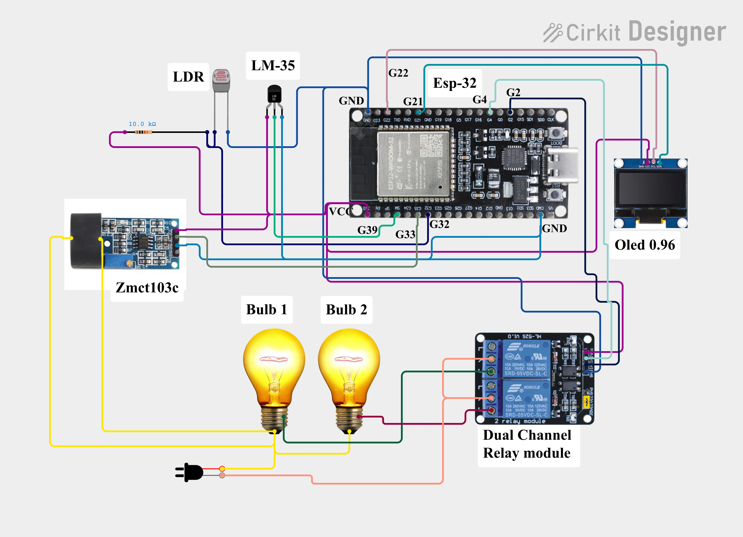

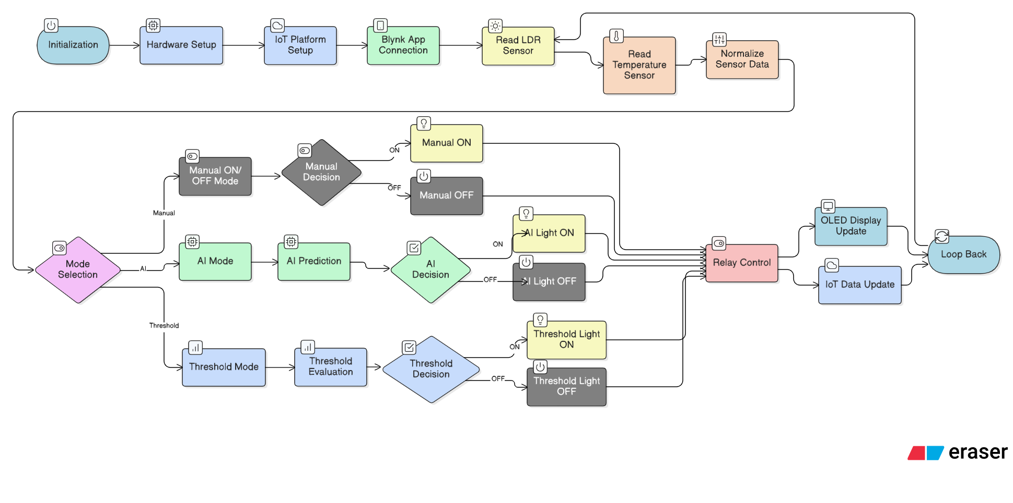
9. Logical Flow and Control Strategy Representation

10. Data Collection and Real-World Scenario Mapping
Scenario | LDR | Temp | AI Prediction | Light Action | Folder Path
Early morning (low light) | 300 | 15 °C | Dim (0) | 🔆 Light ON | ….\lidar_test\Dataset\data_morning
Late morning (bright) | 1200 | 22 °C | Bright (1) | 💡 OFF | ….\lidar_test\Dataset\after_sunset_20mint.csv
Noon (glare sunlight) | 1650 | 28 °C | Glare (2) | 💡 OFF | ….\lidar_test\Dataset\data_noon
Cloudy outdoor | 1100 | 19 °C | Bright (1) | 💡 OFF | ….\lidar_test\Dataset\data_noon
Indoor lights off | 400 | 17 °C | Dim (0) | 🔆 ON | ….\lidar_test\Dataset\indoornoon
Indoor lights on | 900 | 20 °C | Bright (1) | 💡 OFF | ….\lidar_test\Dataset\indoornoon
Evening sunset | 450 | 16 °C | Dim (0) | 🔆 ON | ….\lidar_test\Dataset\noondata
Night (streetlight) | 280 | 14 °C | Dim (0) | 🔆 ON | ….\lidar_test\Dataset\night_ambient
High-temperature test | 1100 | 30 °C | Glare (2) | 💡 OFF | ….\lidar_test\Dataset\sunset_time
Fan/cool air test | 950 | 15 °C | Bright (1) | 💡 OFF | ….\lidar_test\Dataset\sunset_time

11. Machine Learning Model Selection and Tuning
Model | Accuracy | Precision | Recall | F1-Score | MCC
Random Forest | 0.91318 | 0.912595 | 0.91318 | 0.912809 | 0.869844
Decision Tree | 0.910031 | 0.909365 | 0.910031 | 0.90953 | 0.865206
Gradient Boosting | 0.907332 | 0.907758 | 0.907332 | 0.907055 | 0.86146
KNN | 0.878093 | 0.877397 | 0.878093 | 0.87771 | 0.817171
AdaBoost | 0.764283 | 0.781364 | 0.764283 | 0.757254 | 0.661563
QDA | 0.724696 | 0.721882 | 0.724696 | 0.713133 | 0.595495
Logistic Regression | 0.7148 | 0.713953 | 0.7148 | 0.713848 | 0.572688
Naive Bayes | 0.71345 | 0.709095 | 0.71345 | 0.702607 | 0.577369
SVM | 0.677463 | 0.75171 | 0.677463 | 0.685494 | 0.54088

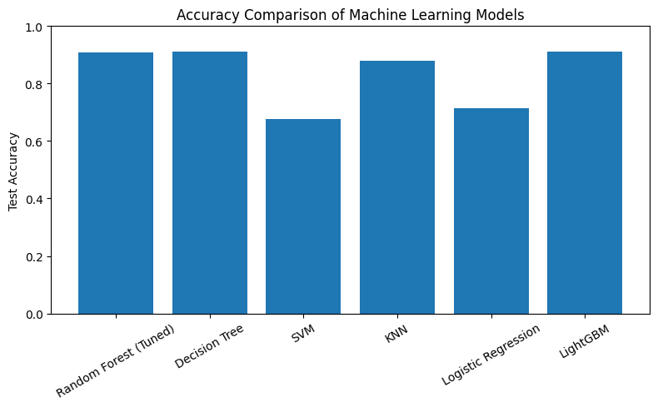

Confusion Matrix of Random Forest
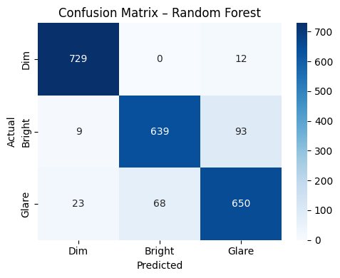

Confusion Matrix of Light GBM
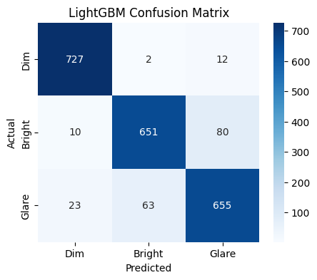
12. Energy Consumption Comparison
Mode | Per hour power Consumption | Per Day Power Consumption | Unit consumes in Month
Threshold | 29.04 Wh | 29.04x11 = 319.44 | 9.583
Ai | 29.04 Wh | 29.04x10 = 290.4 | 8.712

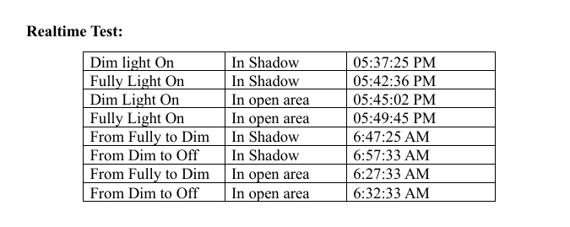

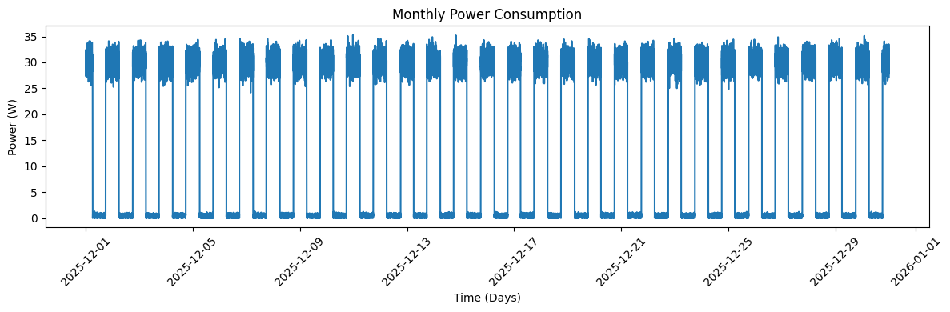
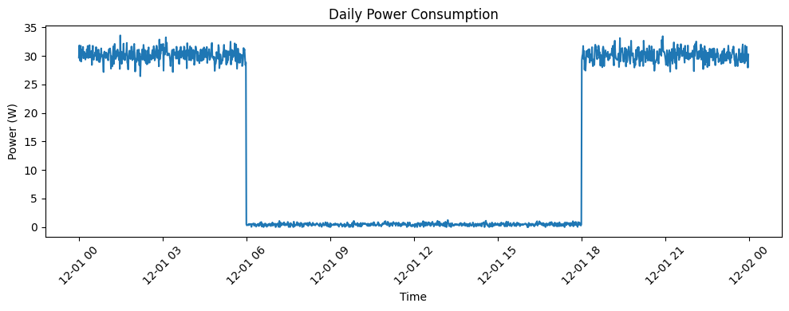

13. Model Size and Edge Optimization Analysis
n_estimators | max_  depth | min_samples_split | min_samples_leaf | Train Accuracy | Test Accuracy | Model Size (KB)
50 | Nan | 10 | 2 | 0.923838 | 0.916329 | 576.5869
50 | 20 | 10 | 2 | 0.923838 | 0.916329 | 576.1943
100 | Nan | 10 | 2 | 0.924063 | 0.916329 | 1152.382
75 | Nan | 10 | 2 | 0.923726 | 0.915879 | 864.5781
50 | 15 | 10 | 4 | 0.922713 | 0.915879 | 513.3213
111 | 20 | 10 | 2 | 0.923951 | 0.915879 | 1276.437
100 | 20 | 10 | 2 | 0.923951 | 0.915879 | 1151.958
111 | Nan | 10 | 2 | 0.923951 | 0.915879 | 1277.691
50 | 20 | 10 | 1 | 0.925188 | 0.91543 | 591.1699

14. IoT Dashboard Data Representation
